TD 5G NR
Exercise 1: 5G NR features
What is, in your opinion, the main factors that make that 5G NR provides a better throughput than LTE and LTE-A?

Exercise 2: Throughput computation
Orange France uses a frequency band of 90MHz in the 3.5Gz spectrum band for the deployment of its 5G NR network. The frequency band is organized into 3000 subcarriers of 30KHz in FDD mode.
What is the maximum theoretical downlink data rate that can be provided by Orange under good radio conditions allowing the use of 256-QAM modulation (normal cp mode)?

Exercise 3: Antenna configuration
5G NR gives many options that allow a better adaptation of the network for the corresponding environment. Using arrows propose for each class of environment, the adequate frequency band, subcarrier wideband and cyclical mode.

Environment | Frequencies | Subcarrier size | Cyclical mode
Paris-centre + dense network  Montbéliard + dense network  Montbéliard + low dense net.  A36 Belfort-Montbéliard  Saint-Jean-Pied-de-Port | 700MHz  3.5GHz  24GHZ | 15KHz  30KHz  60KHz | Normal  Extended

Exercice 4. 5G NR Throughput according to the CQI
Hereafter the correspondence table between the SINR observed by the UE and the CQI.
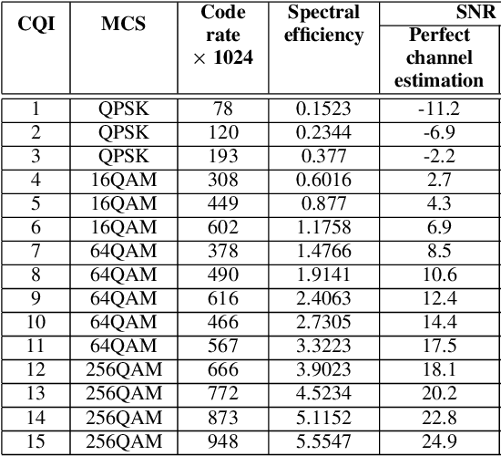
- Calculate the provided 5G NR downlink throughput if the available BW is of 70 MHz, the frequency band is of 4.6GHz, the cyclic prefix mode is extended, the transmission power of the antenna is of 43dBm, the distance of the UE from the antenna is of 1400m. The subcarrier size is of 15kHz. The computing should consider the nose+interference (= -100dBm), and the free space propagation model (loss = 32,45 dB + 20*log [frequency (MHz)] + 20*log [distance (km)]).

- What is the useful download throughput?

